

Release Management

Release Deployment Procedure

STATUS INFORMATION

Security classification: | Confidential |  | State: | Final
Current version number: | 1.1 | Date of first issue: |  | 15/04/2008
Prepared by: | Moussa Bagayoko |  | Date: | 08/04/2008
Verified by: | Moulay Younes Alaoui-Rizq |  | Date: | 15/04/2008
Approved by: | Julien Andrieux |  | Date: | 06/10/2008
Document owner: | Julien Andrieux (act as)
Copyright notice
This document may not be reproduced (even partially) or communicated to third parties without the written authorization of the company’s General Management.
DISTRIBUTION LIST
Name | Address | I/A/V
Julien Simon | julien.simon@digiplug.com | V/A
Julien Andrieux | julien.andrieux@digiplug.com | V/A
Digiplug Managers |  | I/A
IT Operations team |  | A
IT Development team |  | I/A
IT Architecture team |  | I/A
Nicolas Tavier | nicolas.tavier@accenture.com | I
Morgan Le Du | morgan.ledu@accenture.com | I
Moulay Younes Alaoui Rizq | moulay.y.alaoui-rizq@accenture.com | I
Nourou Dine Issaka | nourou.dine.issaka@accenture.com | I
Nicolas Macaire | nicolas.macaire@accenture.com | I
(I = for information, A = for action, V=for validation)
DOCUMENT CHANGE RECORD
Version | Date | Description | Affected sections
0.1 | 15/04/2008 | First communication | All
0.2 | 15/04/2008 | Integration of readers’ comments | All
1.0 | 09/05/2008 | Final version | All
1.1 | 24/09/2008 | Updated and generalized version | All
IT Contact PEople
Function | Name
IT Lead | Julien Andrieux
IT Consultant | Moulay Younes Alaoui Rizq
IT Consultant | Nicolas Macaire
IT Consultant | Nourou Dine Issaka

Table of content

1 Purpose 5
2 Deployment Procedure 6
2.1 Description 6
2.2 Timeframes and intervals 6
2.3 Workflow 7
2.4 Roles and Tasks Description 7
2.5 Related Policies and Procedures 9
2.6 Related Tools 9

Purpose
The Release Deployment Management procedure covers activities needed to deploy new applications and maintenance releases. It can only end with a successful deployment, or with a complete root cause analysis of a failed deployment.

This process includes activities such as planning, notification of changes to business users, confirmation of deployment testing and final review, and change approval.

Please note that only actions performed by the IT team are described in this document.

High Level Process Flow

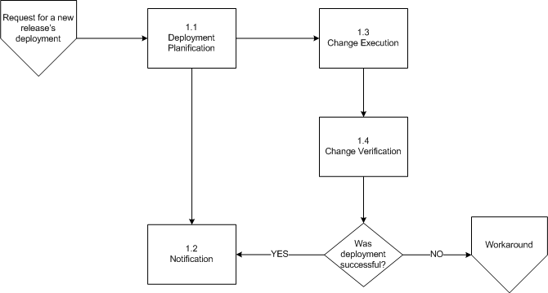

Image 1: High Level Process flow

Deployment Procedure

Description
The purpose of this activity is to deploy scheduled application changes/bug fixes to the production environment, and to notify the change initiator and the Accenture/Digiplug Service Manager in charge of the relationship with the client. Once a change ticket is approved, the Service Manager informs the user of the planned deployment.

Constant communication and collaboration between all appropriate groups must be maintained during each step of the process.

When ready and validated by all stakeholders, a change can be deployed to production. Once the change has gone live, the deployment is checked and appropriate steps are taken, depending on the success or failure of the deployment: inform users of the successful deployment, implement the rollback plan and determine the cause of the failed deployment, etc.

Once the change is successfully deployed and the business situation is returned to normal operations, deployment-related plans are updated, change tickets are closed and business users are informed.

Please notice that all the rules applied here regarding the “production” environment must also be applied to the “pre-production” environment.

Timeframes and intervals
The available timeframes for a planned deployment have to be among these ones:
- Monday to Thursday, from 9.30 am to 5 pm.
- Friday from 9.30 am to 12.30 pm.

In addition, there is a minimal set of operations between a deployment to the pre-production environment, and the corresponding deployment in the production environment, to guarantee proper execution of the tests. This set of operations is made of a detailed test plan including the description and timestamps of the executed steps.

In case of an emergency, this interval can be reduced, but only after written validation by the Digiplug top management represented by the Technical Director.

Workflow

The detailed workflow for release deployment is the following one.

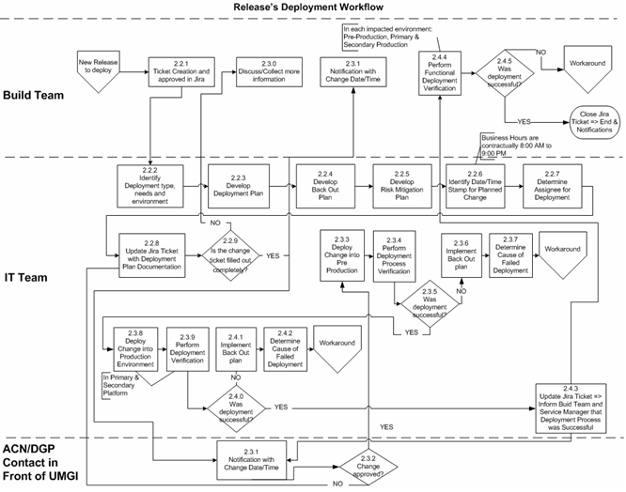
f the client

Image 2: Deployment Process Workflow

Roles and Tasks Description

Build Team
The Build Team is made of all members of Application Development and Architecture Teams. They use their own Development and Integration environment to prepare, test and package a release/bug fix to deploy.

The process within this team to prepare and validate a release is explained in the whole Release Management document.

In this Release Deployment procedure, the pre requisite is that the change decision is already approved by all the stakeholders before coming to the IT Team.

The Build Team members help the IT Team to complete the change ticket. In addition, they may be asked to give more information when necessary. They are also notified at each step and are provided with deployment issues information for the future.

After technical deployment, they have to perform functional tests and verifications to validate the change success.
(Steps 2.2.1, 2.3.0, 2.3.1, 2.4.4 and 2.4.5)

IT Team
The IT Team is the only group authorized to take actions on the Pre Production and Production environments. They:
- identify the change type;
- deploy the change into pre production and production environments;
- perform deployment process verifications;
- implement the back out plan (if the deployment was not successful);
- determine the cause of a failed deployment;
- document the deployment plan and the check out plan;
- document the back out plan;
- document the risk mitigation plan;
- identify a date/time stamp for a planned change;
- determine the assignee for deployment;
- create/update the change ticket with a deployment plan documentation;
- determine if the change ticket is filled out completely.

All changes (scheduled release and bug fixes changes) must be implemented into Pre Production before being transposed to Production.

When deployment actually takes place, the person in charge is also responsible for communication. In case of difficulties, he/she must escalate the issue to the IT Lead. If further escalation is required, the issue may then be communicated to the Technical Director. When deployment is complete, he/she must also communicate.
(Steps 2.2.2 to 2.2.9 and 2.3.3 to 2.4.3)

Accenture/Digiplug Contact Service Manager in front of CLIENTS/PARTNERS/USERS
This team/person is informed about all changes that could impact users, clients and business partners. He/she works closely with the IT Team to schedule all changes, making sure there is minimal impact on users and clients. He/she is in charge of informing users and clients about the date and time of the changes and about the return to normal operations.

The IT Team and the Accenture/Digiplug CSM decide together whether and when the deployment has to take place.
The CSM also decides to whom the deployment date is communicated, and the nature of the information provided to clients, partners and/or users.
(Steps 2.3.1 to 2.3.2)

Planned outages
When an outage is planned, two JIRA tickets must be opened. The first one is the normal ticket for any deployment, managed by the IT Team, describing it technically. The second one, managed by the Accenture/Digiplug contact, gives the client the information they need on this change (date, duration, basic description…). A planned outage must be announced minimum a week in advance.

If an outage is not planned, it is caused by an incident: see the “IT Incident management procedure” for further details.

Related Policies and Procedures
- Release Management procedure
- IT Incident Management procedure
- Configuration Task procedure

Related Tools
JIRA
Specific deployment tools associated with each application/system/equipment.

